E-mail: isms2019@jtbcom.co.jp
Deadline: February 4, 2019 (JST)
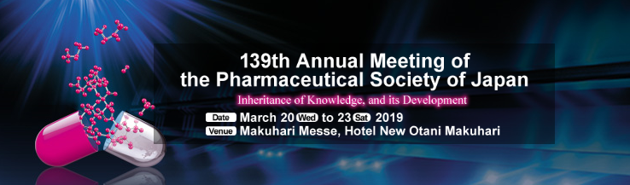
Advance Registration Form
Please type or print information and check appropriate boxes.
Title: ☐ Prof. ☐ Dr. ☐ Mr. ☐ Ms. Gender: ☐ Male ☐ Female
Name | ((Family name)) | ((Middle name)) |  |  | ((Given name))
Affiliation
Department
Post Address
Phone |  |  | Fax
E-mail
Advance Registration Fee:
☐ | JPY 13,000 | Non-Student
☐ | JPY 12,000 | Banquet
JPY |  | Total of the Amount
Confirmation:
On receipt of this form, a confirmation e-mail will be sent to you.
Upon receiving the payment at meeting venue, Name badge and meeting materials will be handed.

Payment:
The Advance Registration Fee will be collected in CASH in Japanese yen at the Registration Desk on-site.

Contact: ISMS2019 Secretariat*
JTB Communication Design, Inc.
E-mail: isms2019@jtbcom.co.jp
*ISMS2019 Secretariat will handle the registration of oversea participants for 139th Annual Meeting of the Pharmaceutical Society of Japan.

